Tiki Products Recommendation System

# Working Backwards

* Users want to discover product they haven’t yet seen that they might enjoy
* Their own behavior (ratings, purchases, views) are probably the best predictors
* As before, availability and partition-tolerance are important. Consistency not so much

# HBase our first choice

* But any NoSQL approach would do these days

# How do product recommendations get into HBase?

* We need to do machine learning
  + **Spark MLlib**
    - **Spark ALS** can actually generate individual product recommendations for you
  + **Flink** could also be alternative
* Timeliness requirements need to be thought out
  + Real-time ML is a tall order – do you really need recommendation based on the rating you just left?
  + That kind of would be nice

# Creative thinking

* Pre-computing recommendations for every user
  + Isn’t timely
  + Wastes resources
* Item-based collaborative filtering
  + Store products similar to other products (these relationships don’t change quickly)
  + At runtime, recommend products similar to ones you’ve liked (based on real-time behavior data)
* So, we need something that can quickly look up products similar to ones you’ve liked at scale
  + Could reside within web app, but probably want your own service for this
* We also need to quickly get at your past ratings/ views/ etc.

# Ok Then.

* So, we’ll have some web service to create recommendations on demand
* It’ll talk to a fast NoSQL data store with product similarities data
* And it also needs your past rating/ purchases/ etc.
* Product similarities (which are expensive) can be updated infrequently, based on log data with views/ ratings/ etc.

# Architecture

­­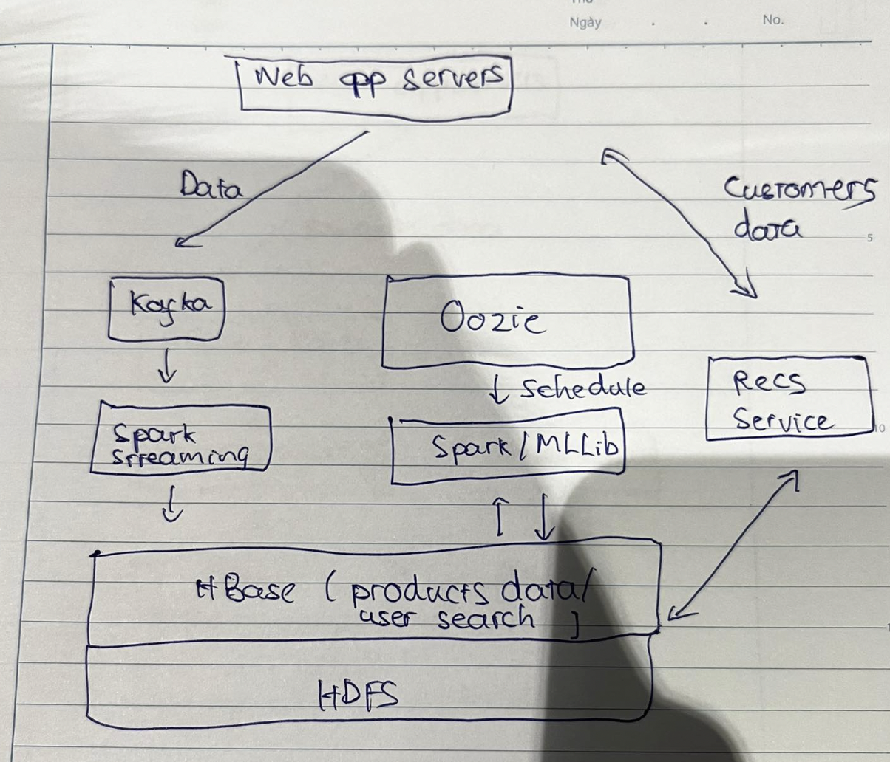

# Scenario

* Data ML: 3 features

# Kafka

* Kafka is general-purpose publish/subscribe messaging system
* Kafka servers store all incoming messages from *publishers* for some period of time, and *publishes* them to a stream of data called a *topic*
* Kafka *consumers* subscribe to one or more topics, and receive data as it’s published
* A stream/topic can have many different consumers, all with their own position in the stream maintained
* It’s not just for Hadoop

# Kafka Architecture

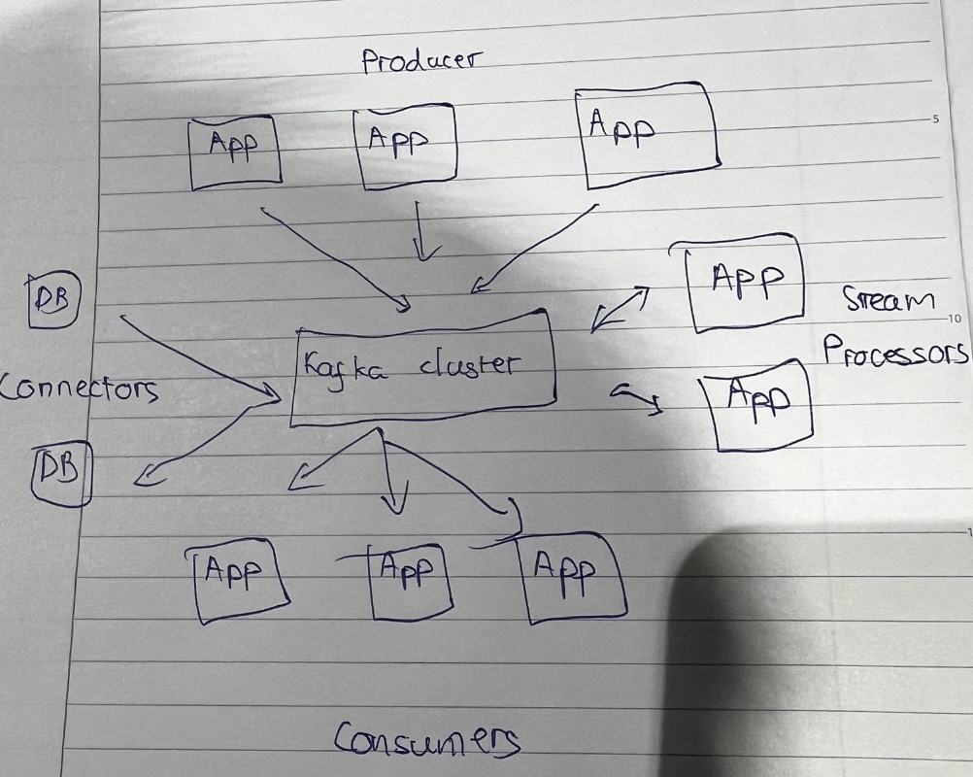

# How Kafka scales

* Kafka itself may be distributed among many processes on many servers
  + Will distribute the storage of stream data as well
* Consumers may also be distributed
  + Consumers of the same group will have messages distributed amongst them
  + Consumers of different groups will get their own copy of each message

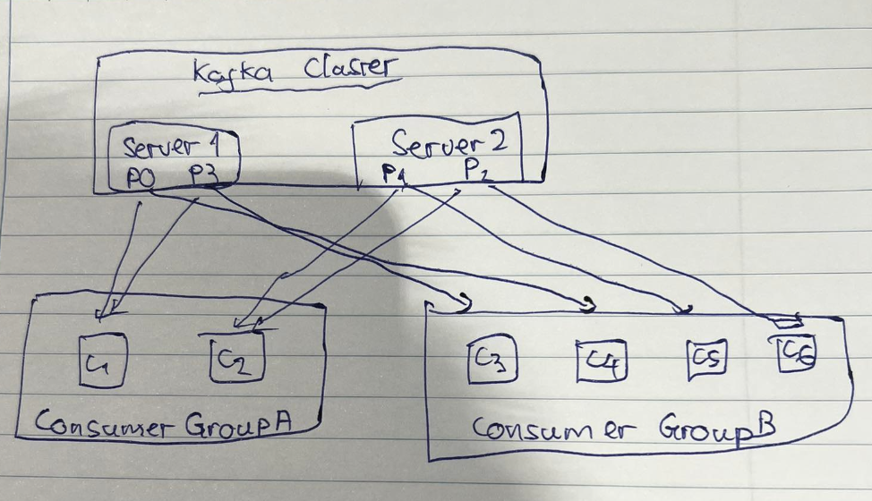

# Visualize

* Products
* Categories

# NoSQL

* When RDBMSs don’t cut it

# NoSQL – Random Access to Planet-Size Data

# NoSQL – Scaling up MySQL etc. to massive loads requires extreme measures

* Denormalization
* Caching layers
* Master/slave setups
* Shard
* Materialized views
* Removing stored producers

# Do you really need SQL?

* Your high-transaction queries are probably pretty simple once de-normalized
* A simple get/put API may meet your needs
* Looking up values for a given key is simple, fast, and scalable
* You can do both

# NoSQL – Sample Architecture

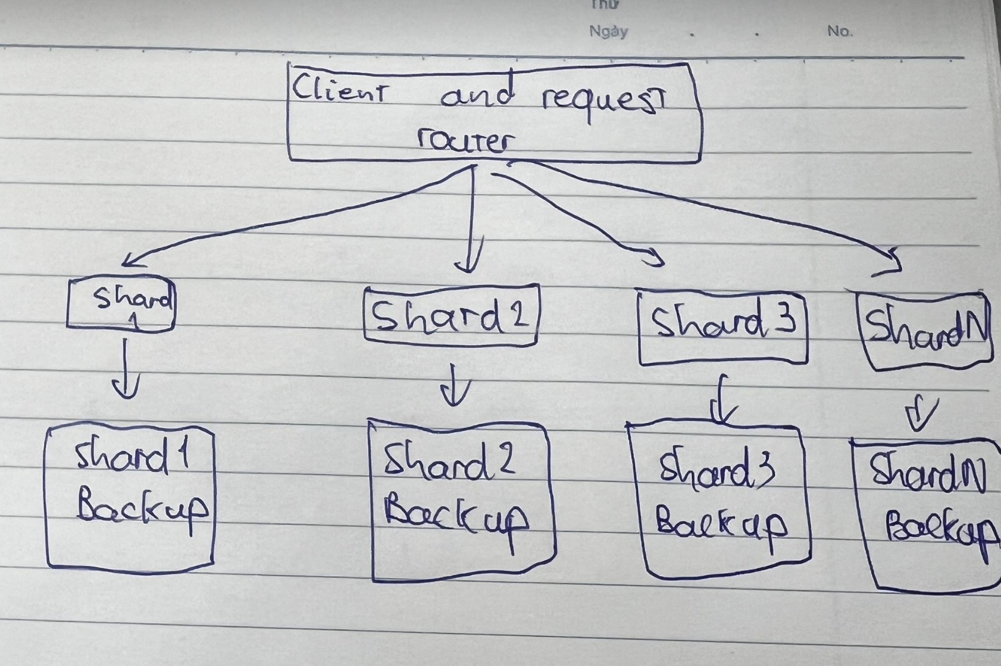

# Use the right tool for the job

* For analytic queries, Hive, Pig, Spark, etc. work great
* Exporting data to MySQL is plenty fast for most application too
* But if you work at giant scale – export your data to non-relational database for fast and scalable serving of that data to web applications, etc.

# Sample Architecture

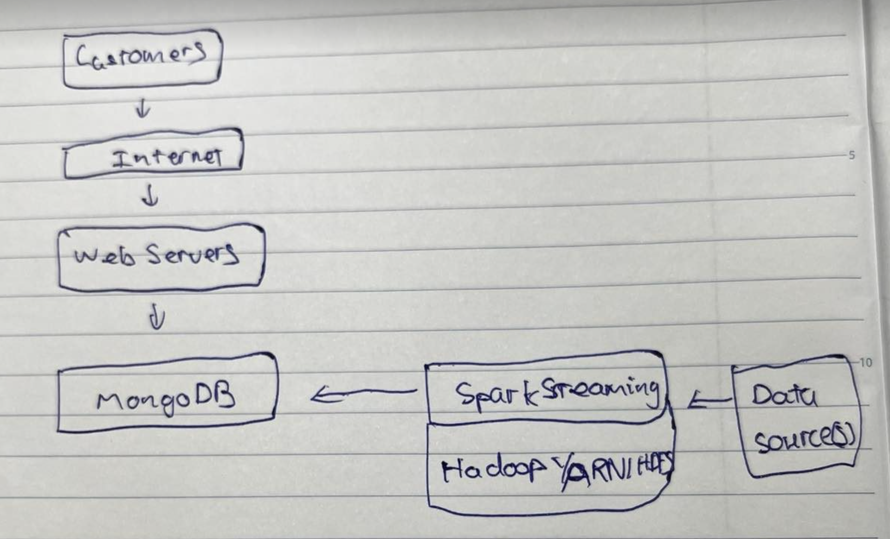

# HBase

* Nonrelational, scalable database built on HDFS
* Based on Google’s Big Table
* CRUD
  + Create
  + Read
  + Update
  + Delete
  + There is no query language, only CRUD API’s

# HBase architecture

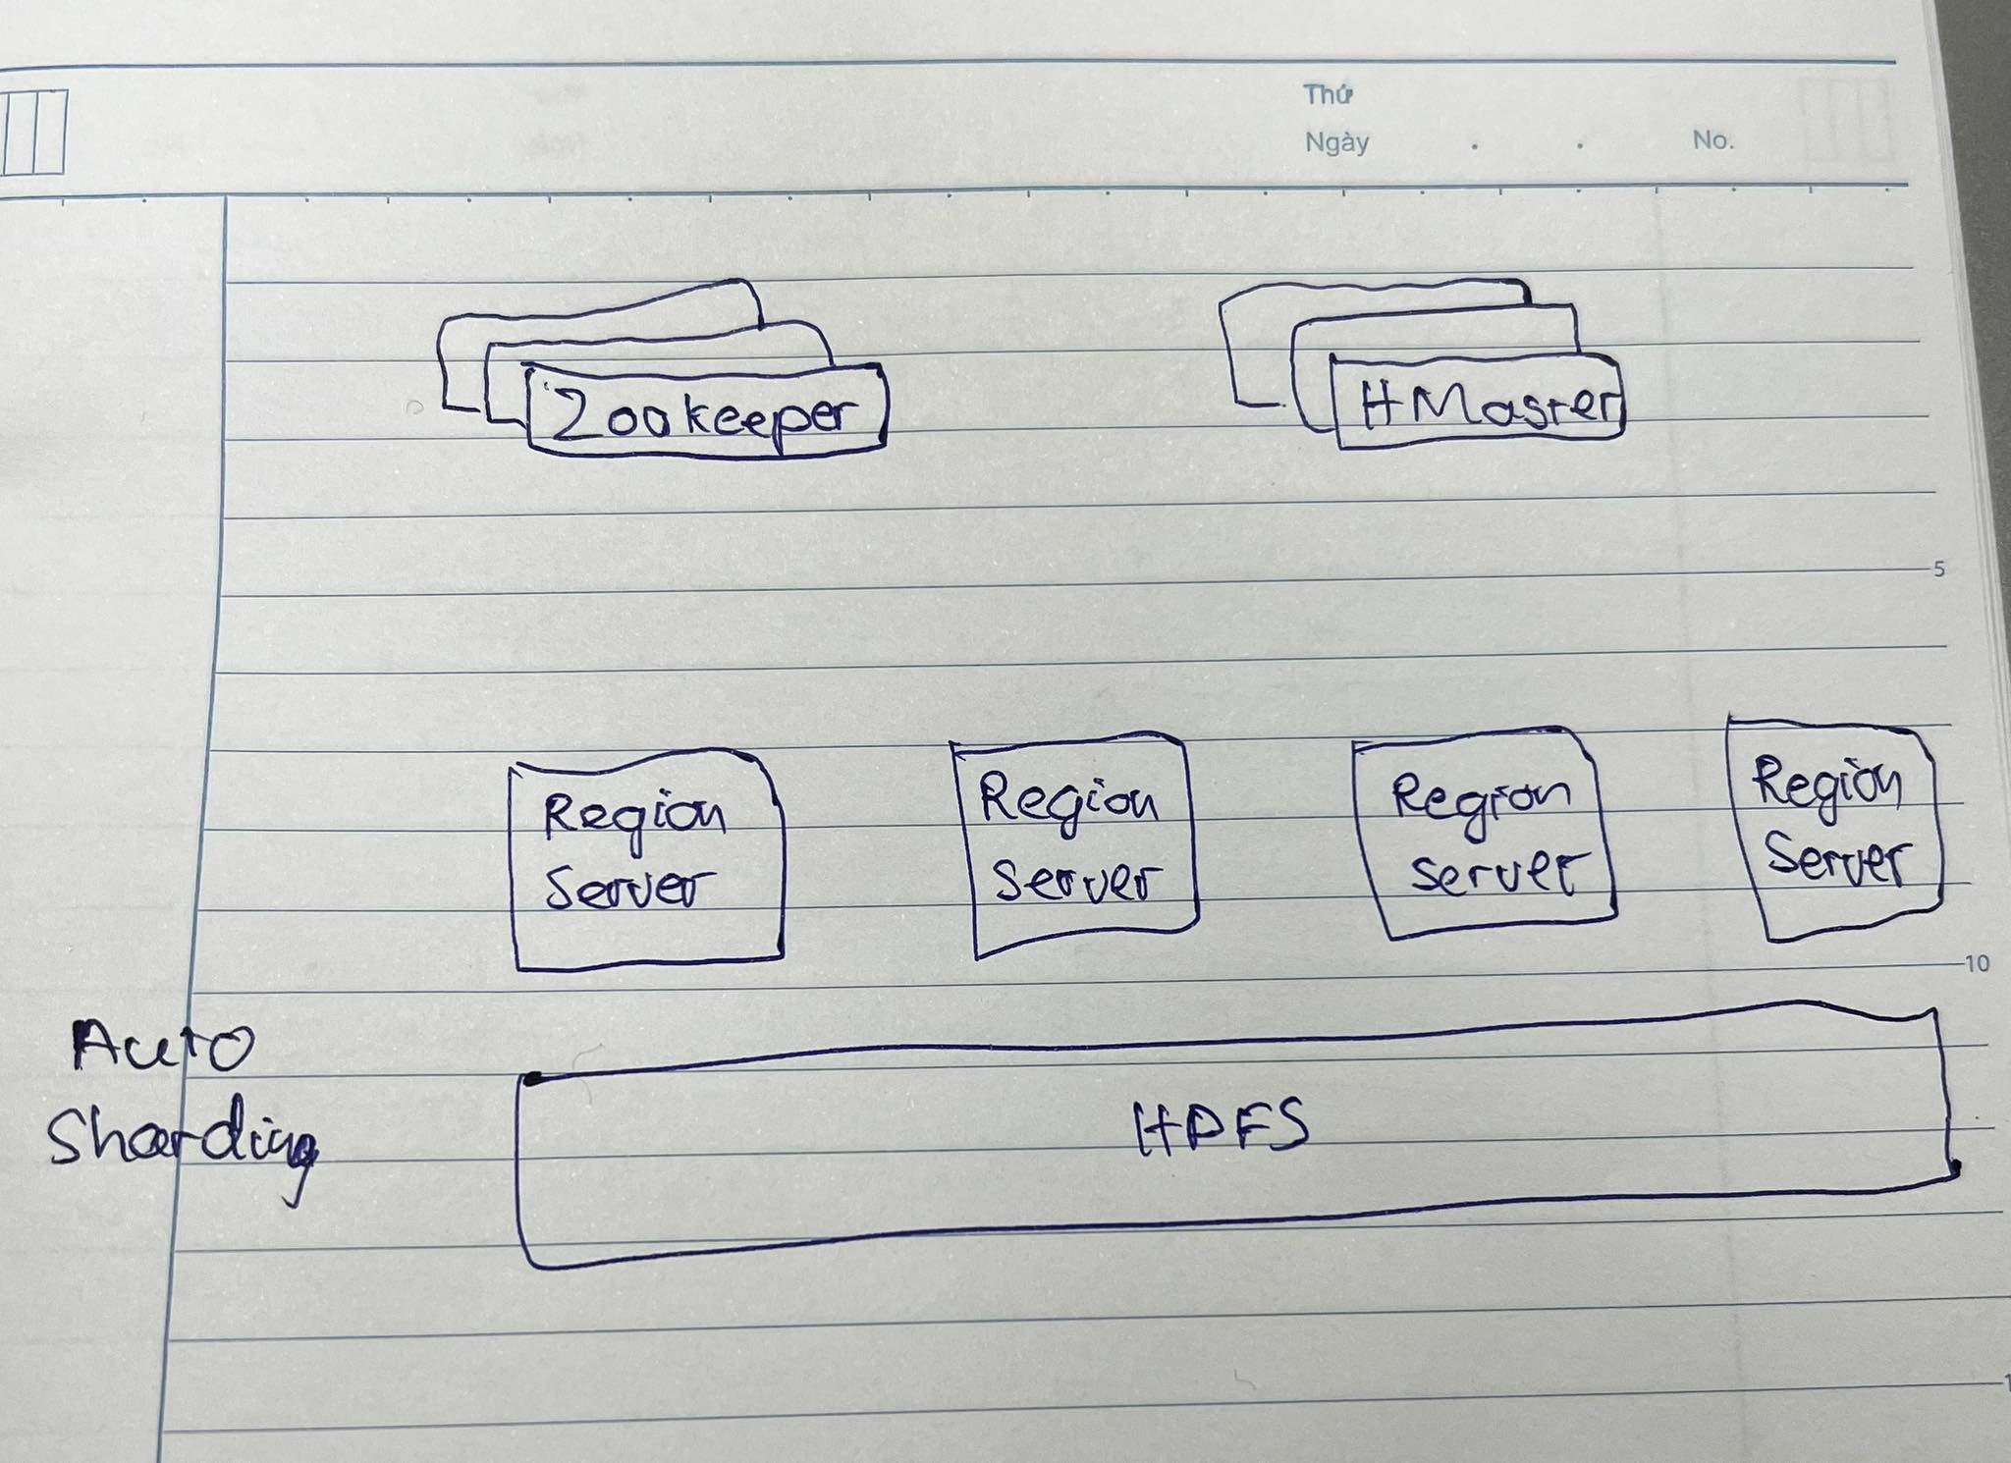

* Partitioned amongst different region servers
* Servers keep track of where everything is and the data itself is actually stored on big files on HDFS

# HBase data model

* Fast access to any given ROW
* A ROW is referenced by a unique KEY
* Each ROW has some small number of COLUMN FAMILIES
* Each COLUMN FAMILY may contain arbitrary COLUMNS
* You can have a very large number of COLUMNS in a COLUMN FAMILY
* Each CELL can have many VERSIONS with given timestamps
* Sparse data is A-OK – missing columns in a row consume no storage

# Example: One row of a web table

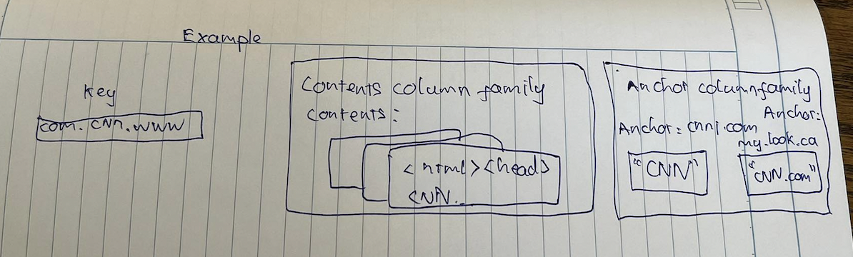

# Some ways to access HBase

* HBase shell
* Java API
  + Wrappers for Python, Scala, etc.
* Spark, Hive, Pig
* REST service
* Thrift service
* Avro service

# What are we doing?

* Create HBase table for movie ratings by user
* Then show we can quickly query it for individual users
* Good example of sparse data

